Student ID: Bida24-212
Student Names: Karabo Wayne Chelane
Student Email: Bida24-212@thuto.bac.ac.bw
Cohort: 2025
Assignment Title: SCIS WMD_2025 A01
Date of Submission: 25 May 2025
Programme of Study: Business Intelligence & Data Analytics
Year of Study: Year 1

- Website Specifications
-Website Objectives: The objective of the KC retailers is to create an online platform that sells football-related merchandise for example, football team kits, to customers based in Southern Africa. The goals include:
- Increasing sales: By providing a great experience for customers, sales can be generated and eventually profit which can be used to grow the business even further.
- Brand Awareness: By showcasing products to football enthusiasts that appreciate the sport, loyalty can be built the business and its customers through providing quality imagery of products and having a user-friendly design.
- Expansion: Another goal is to expand beyond the current available locations on the website by ensuring the website is accessible and useable to a wide audience. This can include the disabled and people in regions with limited access to technology. Breaking down such barriers can ensure expansion is possible.
-Target Audience, Demographics and Technical Aptitude
- Demographics:
- Age: The target market in terms of age is anywhere from the ages of 15 to 35 which is primarily adults and teenagers however growth in the business will allow for an even larger demographic in the future.
- Location: Current locations available are Botswana, South Africa, Zimbabwe and Namibia buas the business grows, more locations will become accessible
- Interests: Football fans, sports enthusiasts and collects of sport merchandise.
- Technical Aptitude: The design of the website prioritizes simplicity ensuring that people with different technological literacy levels can use the website easily. The audience should be comfortable with both online and mobile browsing.

-Type of Website/Content
- Type of website: It is an e-commerce website that focuses on football merchandise.
- Content:
- Product listings (football kits with images, descriptions and prices)
- Checkout Page
- Contact Information
- Responsive design that ensures the website is functional on different devices and web browsers
- Information Design & Taxonomy
The website content is structures such that it ensures ease of navigation.
- Categories:
- Home: It introduces the business and allows for easy access to the shop.
- Shop: Showcases all the products (football kits) with images, descriptions and the prices of the products.
- Checkout: Includes the order form for completing the purchase.
- Contact Us: Shows order confirmation and provides support details.
- Taxonomy:
- Products: Products are organized by football teams (e.g, Barcelona, Manchester United, Real Madrid)
- Checkout Process: Steps are taken one after the other to collect user information (contact, shipping, payment)
- Navigation: Navigation of the website is consistent across all pages to ensure user flow.

Sitemap
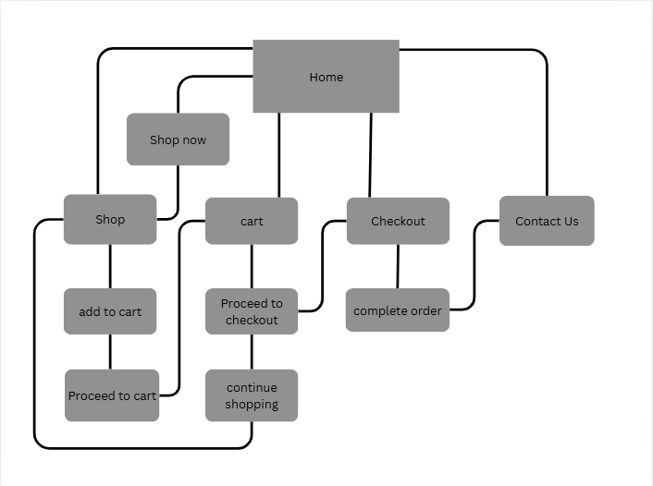
  - Home page(index.html): This is the landing page of the website that has “Shop now” button that directs the user to the next page which is the shop page
  - Shop(shop.html): This is the second page of the website that displays the products being sold and directs the user to the third page of the website which is the cart page once shopping is done.
  - Cart(cart.html): Shows items that have been added to the cart, quantity and the total cost of the items. It has a “proceed to checkout” that directs the user to the next page which is the checkout page and a “continue shopping” that directs users back to the shop page.
  - Checkout(checkout.html): This page collects shipping and payment information for the users and contains a button that directs users to the last page of the website which is the feedback page
  - Feedback(feedback.html): This page contains forms that collects customer reviews and allows the user to rate their experience using the website.
- Technical Brief
Wireframe:
Home Page
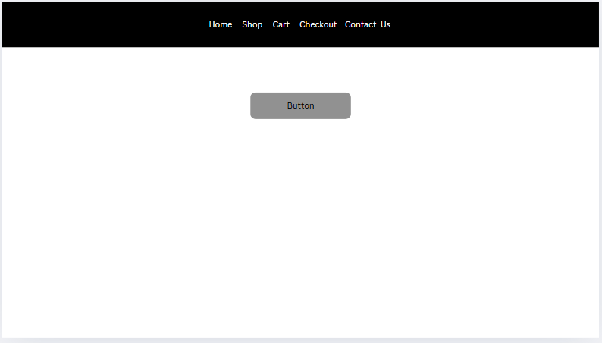

The home page is a simple landing page with a button that takes users to the second page of the website which is the shop page.
Shop Page
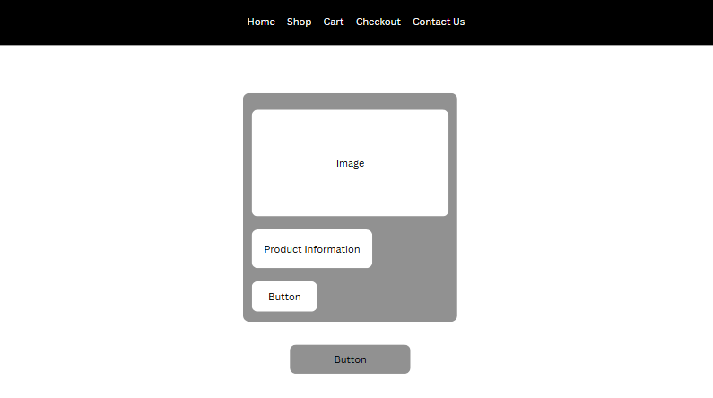
The shop page contains product cards that display the items being sold. The product card displays images of the products with information about the items such as the name and price shown right below it. There is also a button below the product information that adds products selected by the user to a cart. The button below the product card directs users to the cart.

Cart Page
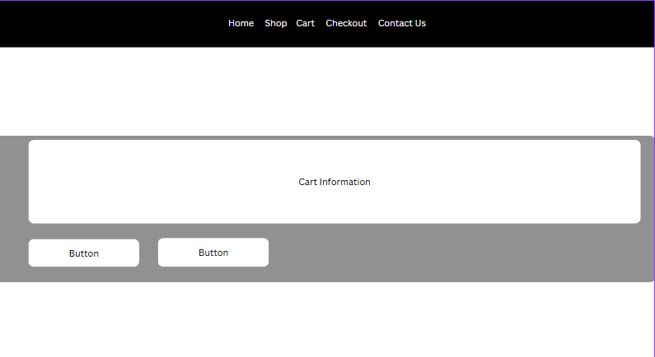
On the cart page, the items selected by the user are displayed and a total price is given. There are also two buttons, one taking the user back to the shop page if any more items need to be added and the other taking the user to the next page which is the checkout page.
Checkout page
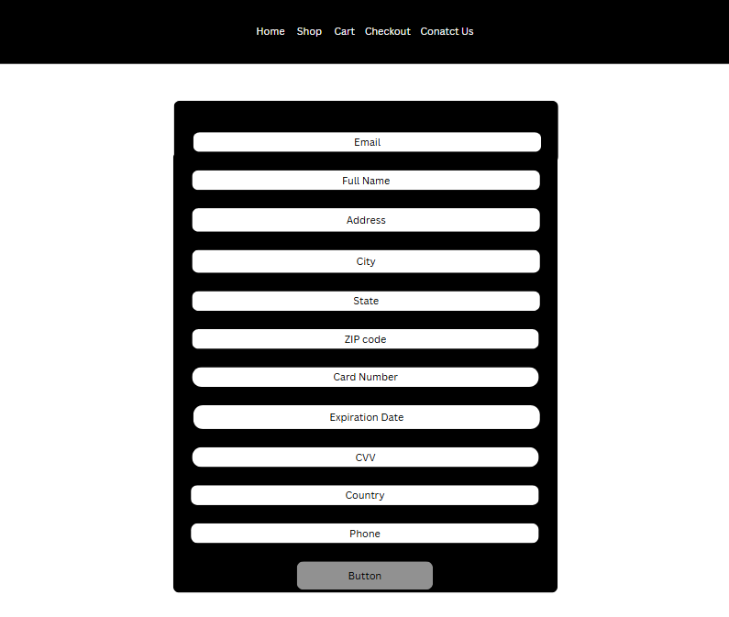
This page contains a form that collects both payment information and the user’s shipping formation. The button below the form directs the user to the last page of the website which is the feedback page.
Feedback Page
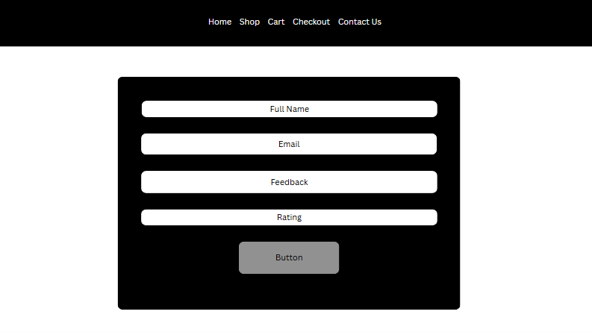
This page contains a form in which the user can give feedback on their experience using the website. The user provides their email address and full name. There is also an option to rate the experience had when using the website.
Navigation Bar
As seen above, the navigation bar is present on all pages to allow the user to navigate to any page on the website regardless of which one they are on at that moment.
- Technical Brief
To develop my website, I used Visual Studio for coding as it supports HTML5, CSS and JavaScript which I used in the production of the website.
- Quality Assurance
I tested the website to check its cross-browser compatibility. Below are screenshots of the website displaying on different browsers.

Google Chrome:
Home Page
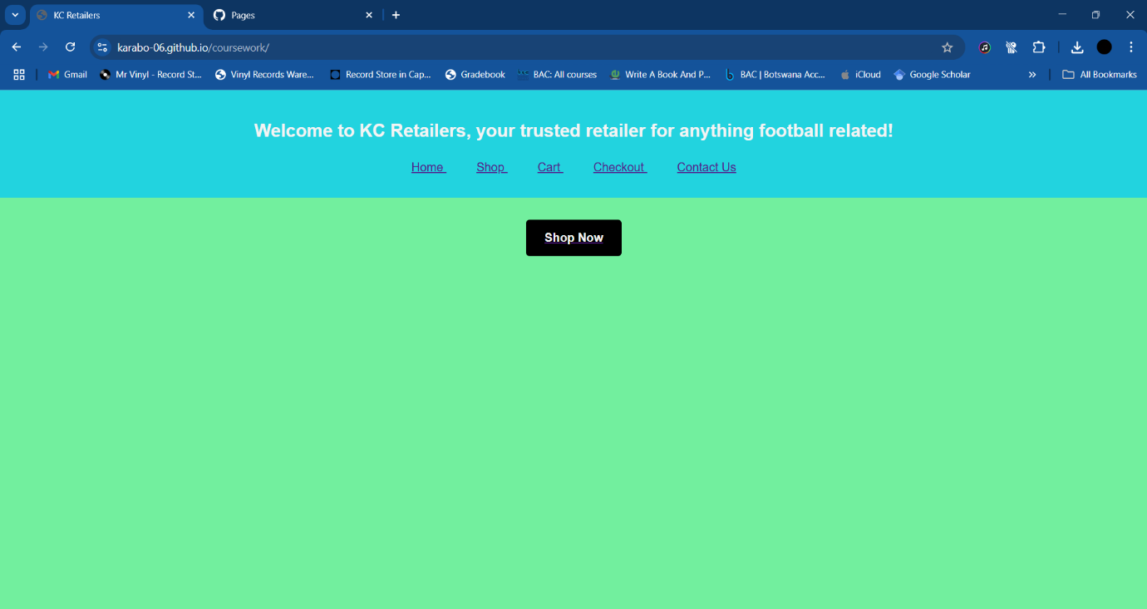
Feedback Page
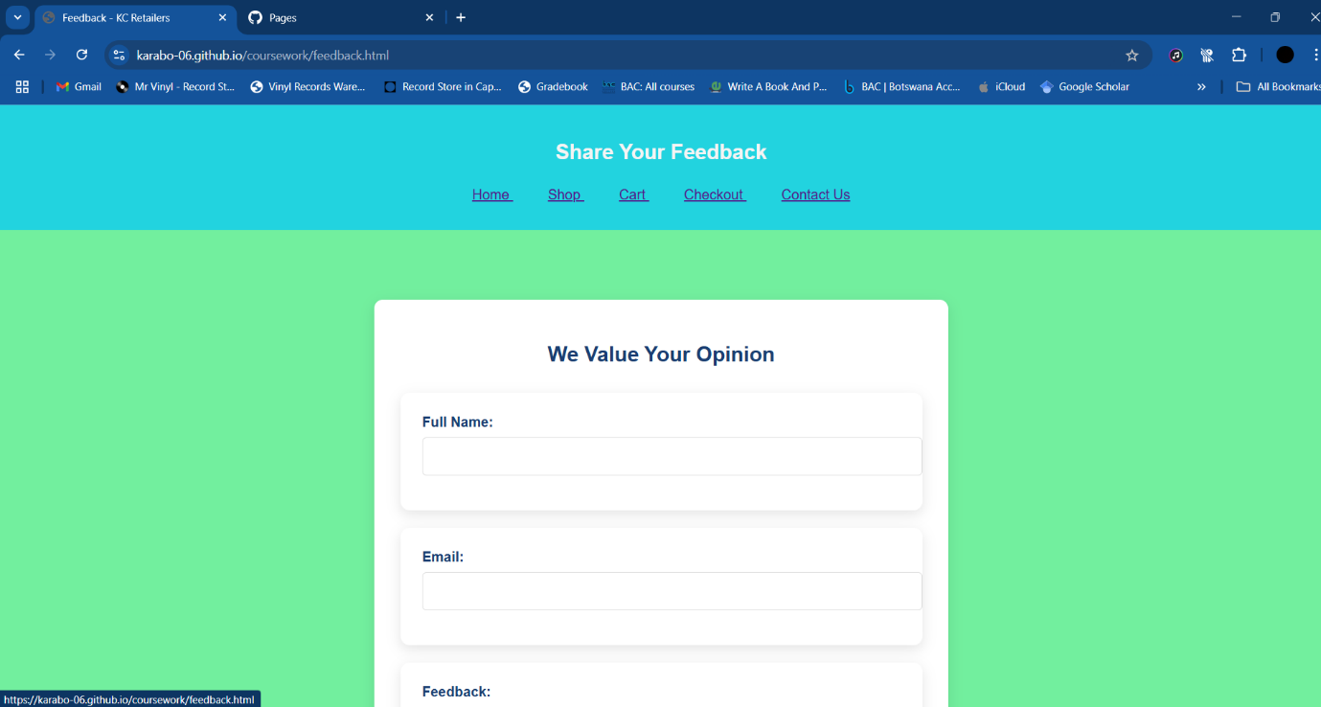
As shown above, the website displays and functions the Google Chrome web browser. The pages on display are the home page and feedback page. Website navigation works properly and is consistent across each page.
Mozilla Firefox:
Home page
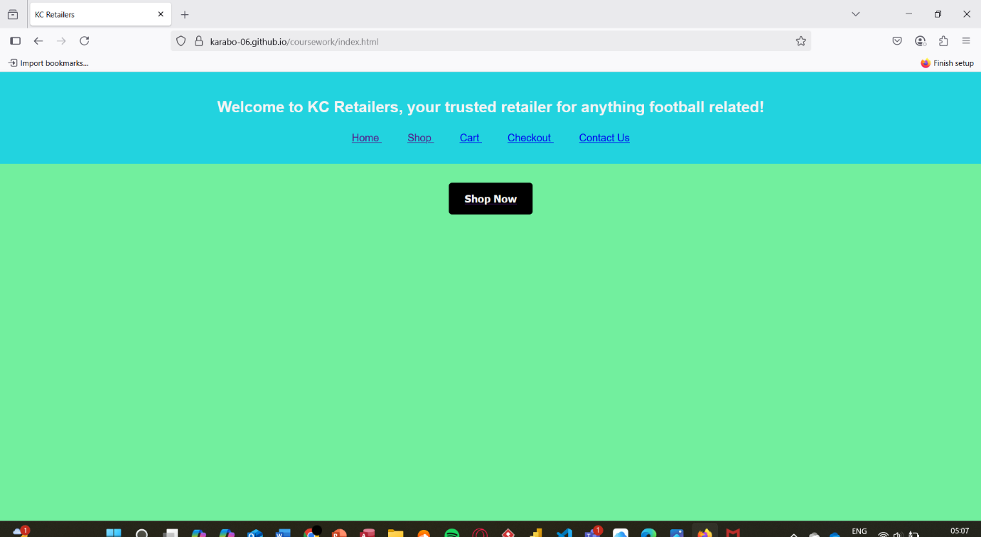
Feedback page
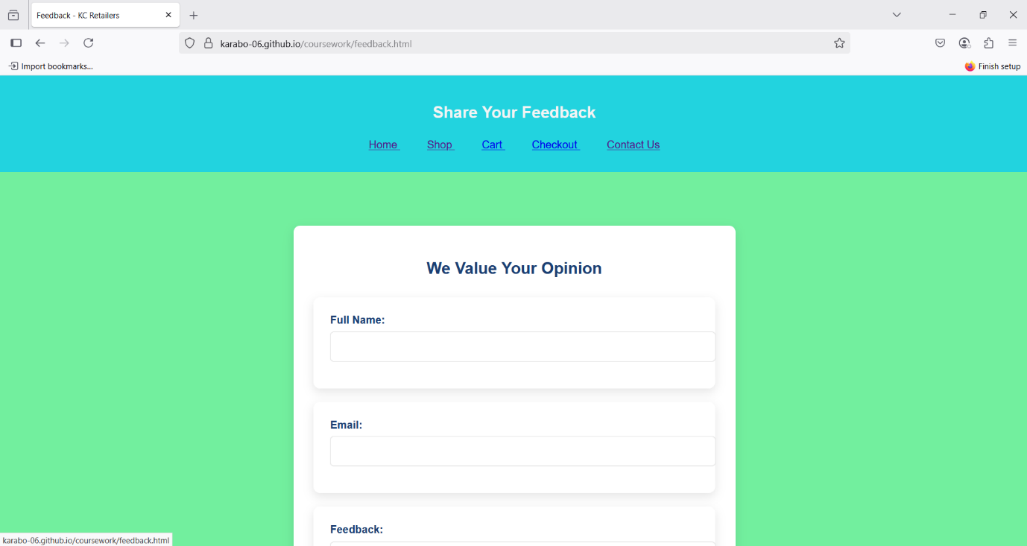
The website displays well on Firefox and functions, with the navigation working properly and is consistent on the browser. Both the home page and feedback page are shown above.
Safari:
Home page
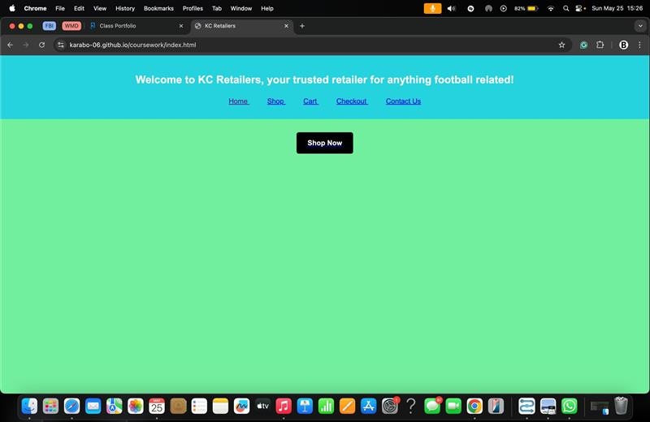
Feedback page
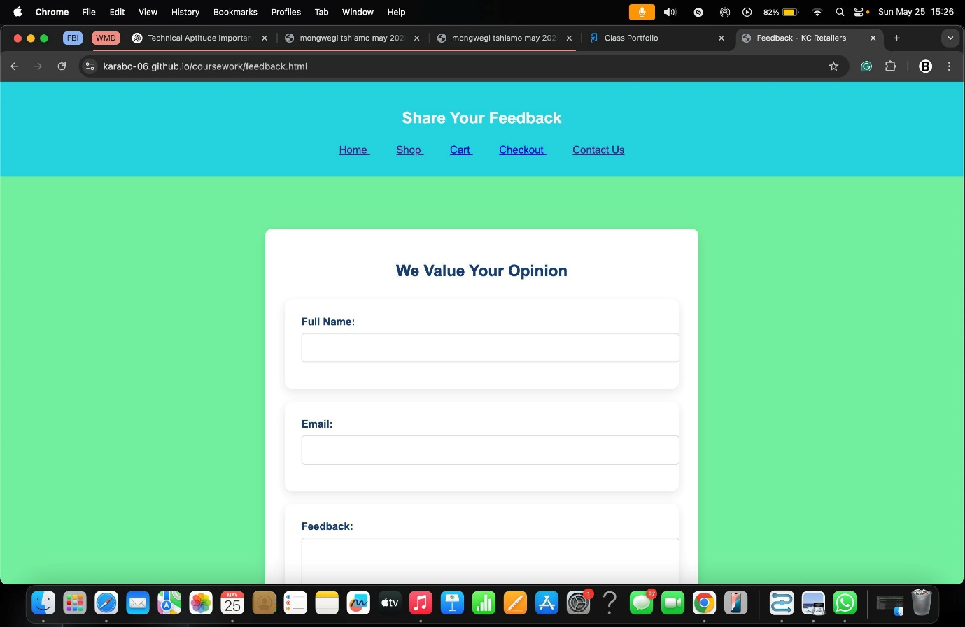
The website displays and functions properly on safari, with all navigation working properly and is consistent on each page on the browser. The home page and feedback page are shown above.
- Publishing & Promotion
To publish the site, I created a repository on Github. Once the repository was created, I uploaded the HTML and CSS files to Github. Once the uploaded files were processed, a URL was generated for the website.
- Future Developments
With the website being centred around e-commerce, any future developments would work towards improving this aspect of the website. Developments that can be made in the future are:
  - Adding user authentication: User authentication can be added to ensure that any purchases made by users can be safely identified and tracked to ensure security when shipping.
  - Expand product categories: At the current moment, the website sells one type of product which are football jerseys. In future, the product catalogue can be expanded to include more products that are football related such as footwear.
  - Branch into other countries: At the current moment, shipping is only available to countries in southern Africa. As the business grows and more sales are made, more countries will be added to the website
Website Link: https://karabo-06.github.io/coursework/
Repository Link: https://github.com/Karabo-06/coursework

